Unit 2

Family

Lesson 1

Grammar and Vocabulary

Exercise 1
Complete the sentences with the words in the box.
aunt children cousin dad daddy grandchildren mum mummy nephew niece parents uncle

- …..Dad….. is an informal word for father.
- The son of your mother’s or father’s sister is your ……………….
- The sons and daughters of your daughter are your ……………….
- Your father’s or mother’s sister is your ……………….
- Your mother and father are your ……………….
- ………………. is an informal word for mother.
- Your brother or sister’s son is your ……………….
- Your sons and daughters are your ……………….
- ………………. is a word for father that young children use.
- Your mother’s or father’s brother is your ……………….
- ………………. is a word for mother that young children use.
- Your brother’s or sister’s daughter is your ……………….

Exercise 2
Complete the email with possessive adjectives (my, your, his, her, its, our, their).


Hi Jack
How is (1)……………… new house in Dublin? (2)……………… your brother is in Dublin too - (3)……………… name’s Ronan Dodd and he’s got a small restaurant. (4)……………… name is Pizza House. (5)……………… wife is a doctor. (6)……………… name’s Mary. He’s got 2 children. (7)……………… names are Ella and Tom. So, phone them - (8)……………… telephone number is 018412617.
Jack <jack107@aol.com>
New house

Exercise 3

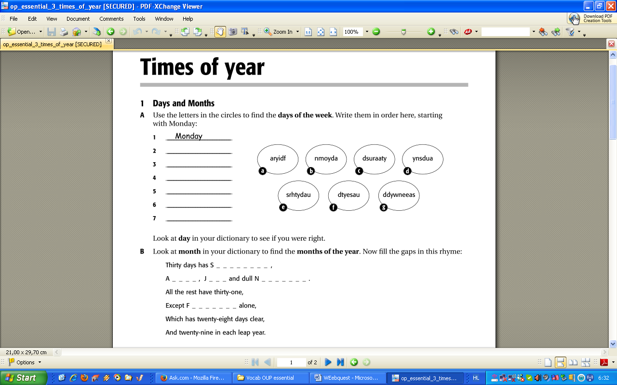

Exercise 4
Find http://learnenglishteens.britishcouncil.org/grammar-vocabulary/vocabulary-exercises/appearance and revise some basic vocabulary for appearance. Then do the some of the activities that follow.
- Image matching
- Find the pairs
- Hangman

Exercise 5
Find http://learnenglishteens.britishcouncil.org/grammar-vocabulary/grammar-videos/have-got, watch the video and correct the following sentences.

- He’s green eyes. ……………………………………………….
- We got have two dogs and a cat. ……………………………………………….
- She got a brother and a sister. ……………………………………………….
- They no have got any chilli peppers. ……………………………………………….
- Have Daisy got a new boyfriend? ……………………………………………….
- We have got no many ideas. ……………………………………………….
- Has you got the time? ……………………………………………….
- Does he has a pencil? ……………………………………………….
- Tim’ mother is a doctor. ……………………………………………….
- The dogs’s bones are in the backyard. ……………………………………………….
Reading
Exercise 6
Read the following text and do the activities that follow.

Weddings
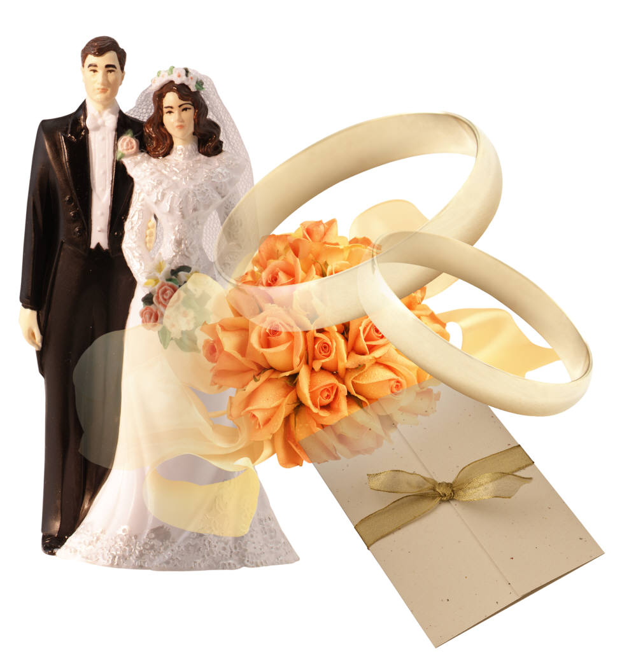
Olga
For us it’s quite normal to have two weddings. I had two weddings. The first wedding is the civil ceremony which everyone has. Then, if you want, you can have a church wedding. In Germany we also have a special evening called Polterabend. People bring old cups and plates and they throw these on the floor! This is great fun, and we make a lot of noise! Then the new couple sweep up the broken pottery together. ________________

Manuela
In Colombia we have a very beautiful candle ceremony. There are three candles, the bride lights the candle on her right and the groom lights the candle on his left. Then, together, the new husband and wife light the middle candle. Now there are three burning candles. Then the two candles on the left and right are blown out and the middle candle is left to burn alone. I was so happy doing this! _____________________

Meryem
There are many different kinds of wedding ceremonies in Turkey. Some brides have a separate celebration with their own family and can’t see their future husband until the day of the wedding. We have a funny tradition with the bride’s shoes. Her girlfriends write their names in her shoes. At the end of the day the bride looks into her shoes. If someone’s name is missing that means they are the next person to get married. My sister was very happy because her name was no longer there. __________________

Noshilu
In Kenya and Tanzania the Maasia tribe have quite a simple wedding. The bride wears all her jewellery – lots of earrings, necklaces and bracelets. The most important necklace is the one made by the bride’s mother. It’s always very beautiful and sometimes it can be very long. My necklace went down to my knees! My new husband came to my family’s home and walked me to his family’s home. I was then given some cows as a wedding present which now belong to my husband. __________________

Lin
Our weddings have a lot of red because for us it’s the colour of love, wealth and happiness. My wedding gown was the traditional red, and so were the invitations I sent out to our guests. The wedding gifts from my husband’s family were in red baskets. Nowadays in China it’s quite usual to have a video made in a park. The bride and groom give each other handkerchiefs with a picture of a duck on because ducks always stay together. And the colour of the hankies? __________________

Barbara
There are many different kinds of weddings depending on where your family comes from. You can get married in a hall, on the beach, at home – wherever and however you want. It’s also possible in the US to get married only a few hours after you propose. I was on holiday in Las Vegas and my boyfriend decided he wanted us to get married so we did! __________________

1 Which is the final sentence to each paragraph?

a) She got married six months later!
b) Why, red of course!
c) Our holiday became our honeymoon!
d) This is to bring good luck and to stop anything bad breaking in the new home.
e) That’s it!
f) It shows that the husband and wife are now one body and will live their life together.

2 Are the following sentences about the reading true (T) or false (F)?

a) Only five of the women are married.
b) In Germany everyone has a church wedding.
c) In Colombia couples light three candles and then blow out two.
d) In Turkey people write in the groom’s shoes.
e) The Maasai bride keeps her wedding present.
f) In China people give ducks as wedding gifts.
g) In the US you can get married very quickly.

