Unit 3

School

Lesson 1

Grammar and Vocabulary

Exercise 1
Match the words and the pictures.










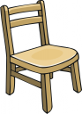
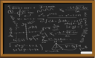
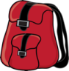



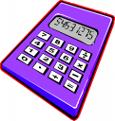



1 desk
2 notebook
3 map
4 door
5 picture
6 sponge
7 crayon
8 pen
9 scissors
10 teacher
11 chair
12 blackboard
13 schoolbag
14 teacher’s desk
15 student
16 computer
17 calculator
18 glue
19 book
20 pencil case

Exercise 2
Watch a video at http://learnenglishteens.britishcouncil.org/grammar-vocabulary/grammar-videos/adverbs-frequency and do the following activities.

a) Write the words and phrases into the correct group.

occasionally hardly ever seldom once a month never
every Wednesday sometimes quite often on Mondays three times a week

Before the main verb  e.g. I _________ go swimming | At the end of the clause  e.g. I go swimming _________

b) Write the word or phrase in the correct place.

1. I ____________ think ____________ about ____________ becoming a pilot. (sometimes)
2. The Queen ____________ celebrates ____________ her birthday ____________. (twice a year)
3. We ____________ play ____________ computer games ____________. (in the evening)
4. You ____________ think ____________ about ____________ your future. (hardly ever)
5. I ____________ have ____________ seen ____________ her before. (never)
6. I ____________ use ____________ the school library ____________. (most afternoons)
7. My parents ____________ go ____________ to the cinema ____________. (about once a year)
8. I ____________ don’t ____________ wear ____________ black in summer. (normally)

Exercise 3
Put the story in order.

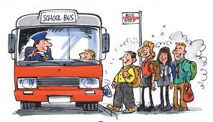
  - where he learnt to read and write.
  - He stayed there until he was sixteen,
  - When Tom was three,
  - and then he went to college.
  - After that, he went to secondary school.
  - He left college when he was 18
  - At the age of five,
  - he started nursery school.
  - he went to primary school,
  - and got a job in a bank.

1 | 2 | 3 | 4 | 5 | 6 | 7 | 8 | 9 | 10

Exercise 4
Find http://resources.woodlands-junior.kent.sch.uk/customs/questions/education/ and answer the following questions.

  - What uniforms do British children usually wear?

a) grey or black trousers/skirts, a white shirt/blouse and black shoes
b) green or blue trousers/skirts, a red shirt/blouse and black shoes
c) white trousers/skirts, dark shirt/blouse and a tie

  - What tests do British students need to take at the age of 10-11?

    - GSCEs
    - GNVQs
    - SATs

  - When does a typical day at a British school start?

    - at 8.45
    - at 9.30
    - at 8.55

  - What subjects do NOT children learn at primary school in Britain?

    - Drama
    - Humanities
    - English

  - How many terms are there in British schools?

    - 2
    - 4
    - 6

Exercise 5
Watch a video at www.youtube.com/watch?v=4onuhAUc2Es
Then decide whether the statements are true (T) or false (F).

  - A student has to wake up early.
  - A student must wear gang-related clothing and hats.
  - A student must wear low-cut skirts.
  - A student has to take a late slip.
  - A student must keep clean the campus.
  - A student must look at his friend’s paper to see their answers.

Reading

Exercise 6
Look at the poster and do the tasks that follow.

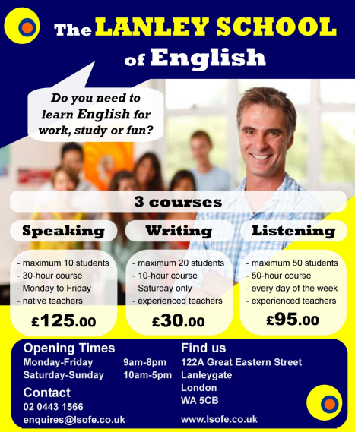

1. Circle the best answer for these questions.

1. In which city is the language school? Liverpool London
2. How many courses are there? three four
3. When can you practise speaking? weekdays weekends
4. How much is the writing course? £30 £95
5. How long is the listening course? 30 hours 50 hours
6. How many students in a speaking class? Maximum 10 Maximum 20
7. What time does the school open on Wednesday? 9:00am 10:00am
8. What time does the school close on Sunday? 8:00pm 5:00pm

2. Match the two sentence halves and write a – h next to the number 1 – 8.

1…….. Lanley School is a. in London.
2…….. You can practise writing b. closes early.
3…….. You can practise listening c. every day.
4…….. A listening course d. lasts 50 hours.
5…….. A speaking course e. very experienced.
6…….. The teachers are f. on Saturday.
7…….. At weekends, the school g. reading course.
8…….. Lanley School doesn't have a h. lasts 30 hours.

