Unit 4

Animals and Humans

Lesson 1

Grammar and Vocabulary

Exercise 1
Look at the following picture and count the animals you can see. Give their names as well.

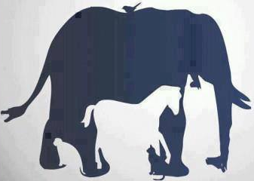
___________________________________
___________________________________
___________________________________
___________________________________
___________________________________
___________________________________
___________________________________
___________________________________
___________________________________

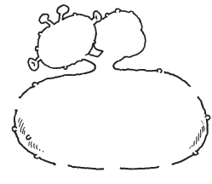
Exercise 2
Read and complete the monster.

It’s got one neck and two heads.
1 It’s got three arms.
2 It’s got blue hair.
3 It’s got six eyes.
4 It’s got four mouths.
5 It’s got five legs.
6 It’s got twelve toes.

Exercise 3
Draw a line from each animal to their picture and then to their groups.

Animal | Picture | Group
Butterfly | 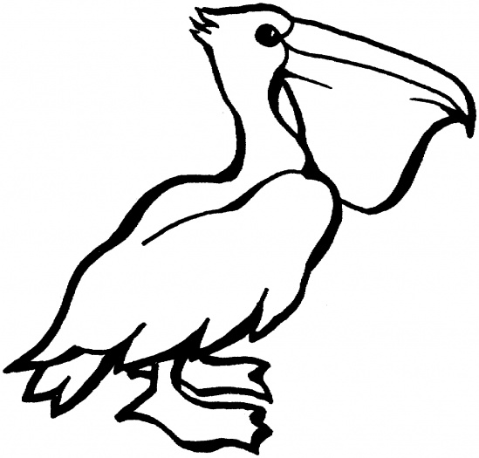 | fish
Pelican | 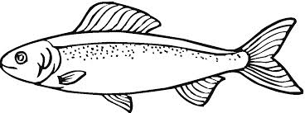 | bird
Salmon |  | insect
Scorpion | 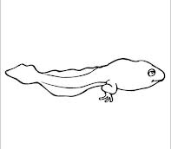 | arachnid
Tadpole | 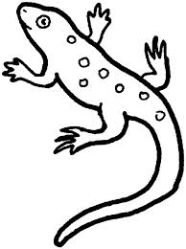 | amphibian
Lizard | 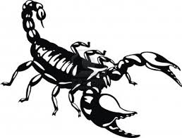 | reptile
Sea urchin | 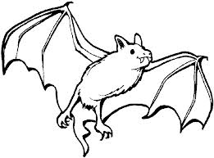 | crustacean
Crab | 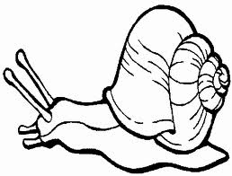 | mammal
Bat | 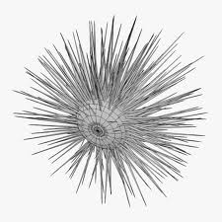 | mollusc
Snail | 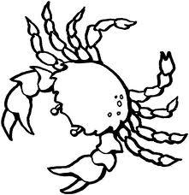 | echinoderm

Exercise 4
Listen to Episode 1 of The Flatmates at http://www.bbc.co.uk/worldservice/learningenglish/flatmates/episode01/index.shtml and choose the best reply to each of the following questions.

1. She's tall and slim and …
a. have got green eyes c. has got green eyes
b. has got eyes green d. green eyes

2. Some people think my dad's quite …
a. matronly c. built well
b. handsome d. shaved head

3. "He's really funny" is the answer. What's the question?
a. What is he like? c. What does he look like?
b. What does he like? d. What like is he?

4. "He's gorgeous - he's tall and he's got big brown eyes." What are the three "he's"
short for in that sentence?
a. he is, he is and he is
b. he is, he is and he has
c. he is, he has and he has
d. he has, he has and he has

5. She loves going to parties, meeting new people and being the centre of attention.
She's …
a. shy c. introvert
b. friendful d. extrovert

6. "What does she look like?" is the question. What's the answer?
a. She likes Italian food.
b. She's shy.
c. She's tall and slim.
d. She looks like tall and slim.

Exercise 5
Are you a superstar fan?
Look at the following pictures and complete the bubbles next to them. Who is the best of all?

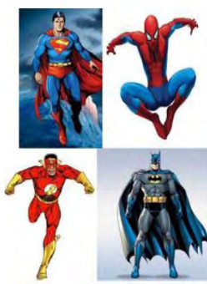
He can…
He can…
He can…
He can…

Reading

Exercise 6
Look at the poster and do the tasks that follow.

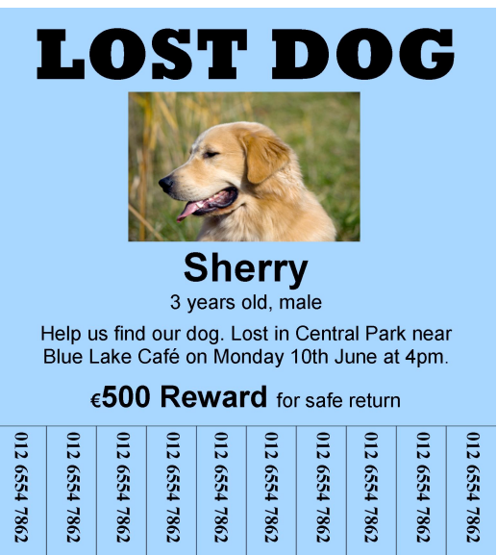

1. Circle True or False for these sentences.

1. The dog is lost. True False
2. The dog's name is Sherry. True False
3. The dog is a female. True False
4. The dog was lost on Monday morning. True False
5. The dog was lost in Central Park. True False
6. There is a reward for finding the dog. True False

2. Complete the lost dog report.

LOST DOG REPORT

You can attach a photo of the dog here.

Dog’s name: ………………………………………..
Age: …………………………………………….…….
Date dog was lost: …………………………………
Time dog was lost: …………………………………
Place dog was lost: ……………………………………………………..
Money offered for finding dog (Euros): ………………………………
3. Correct and write these sentences on the line.

1. The dog is called Berry. ……………………………….…………………….…
2. The dog is five years old. ……………………………….…………………….…
3. The dog was lost on Tuesday. ……………………………….…………………….…
4. Sherry is a female dog. ……………………………….…………………….…
5. Sherry was lost on 10th July. ……………………………….…………………….…
6. Sherry was in Central Cafe. ……………………………….…………………….…

