Unit 5

Home

Lesson 1

Grammar and Vocabulary

Exercise 1
Name the places in the pictures. Use the words on the right. There are TWO extra words you do NOT NEED to use.
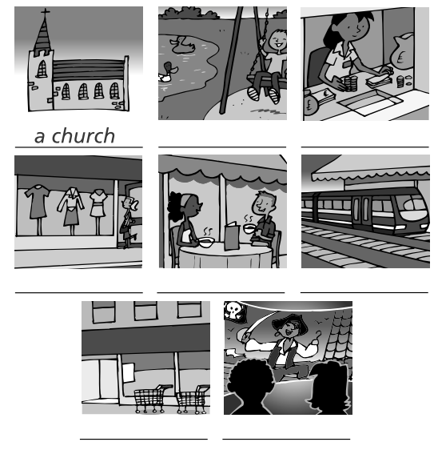

a station
a cinema
a supermarket
a bank
a school
a café
a park
a church
a hospital
a shop

Exercise 2
Look at the picture and choose the preposition to complete the sentences.
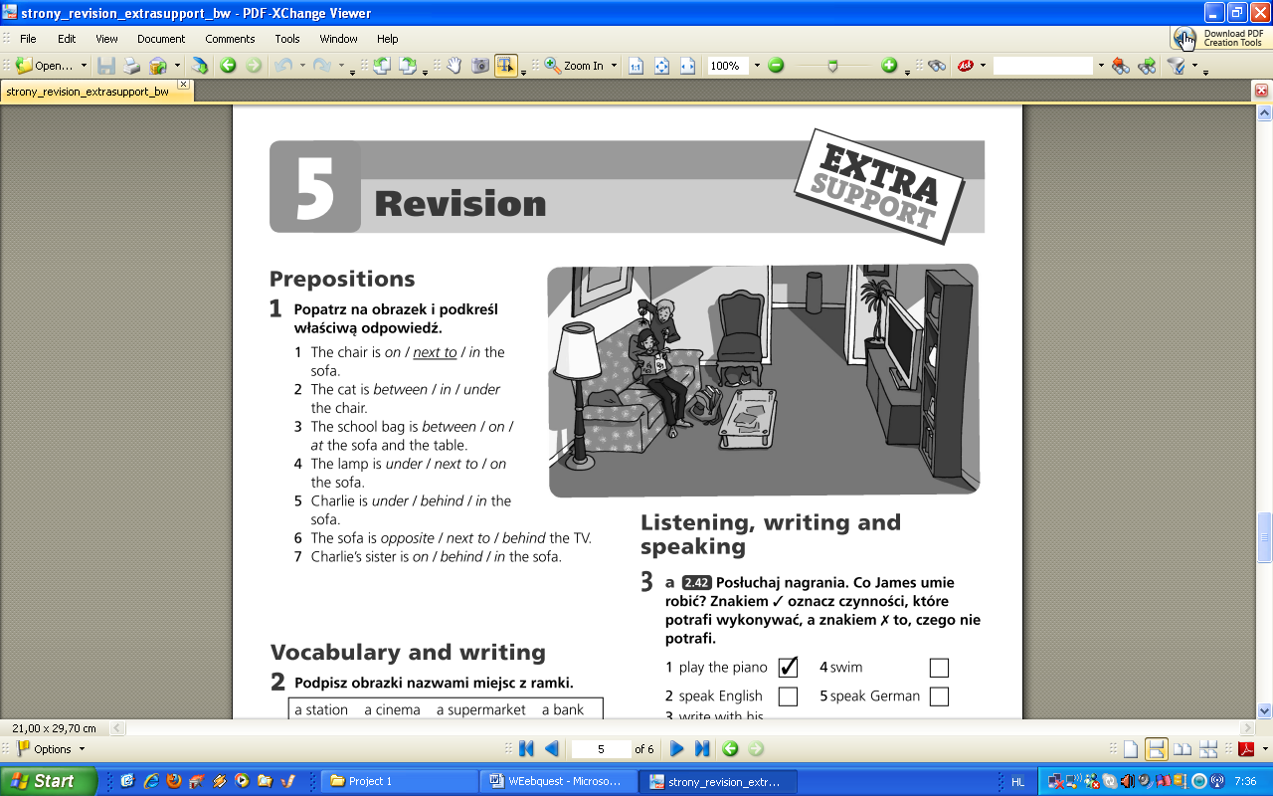
1 The chair is on / next to / in the sofa.
2 The cat is between / in / under the chair.
3 The school bag is between / on / at the sofa and the table.
4 The lamp is under / next to / on the sofa.
5 Charlie is under / behind / in the sofa.
6 The sofa is opposite / next to / behind the TV.
7 Charlie’s sister is on / behind / in the sofa.

Exercise 3

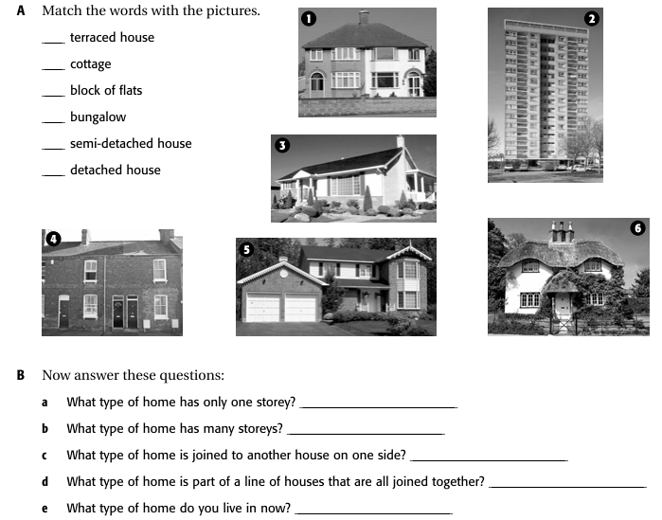

Exercise 4
Present Simple or Continuous? Choose the correct from.

1 “Come on, Vicky. It’s quarter past eight.”
“OK. I get up / am getting up now.”

2 “Is Jess in the garden?”
“Yes, she is playing / plays with Tess.”

3 “Tony is going / goes swimming every Saturday.”

4 “Bye, Mum. We are going / go to the cinema.”

5 “What are you doing?”
“I listen / am listening to the Scissor Sisters on my MP3 player.”

Exercise 5
Complete the crossword.

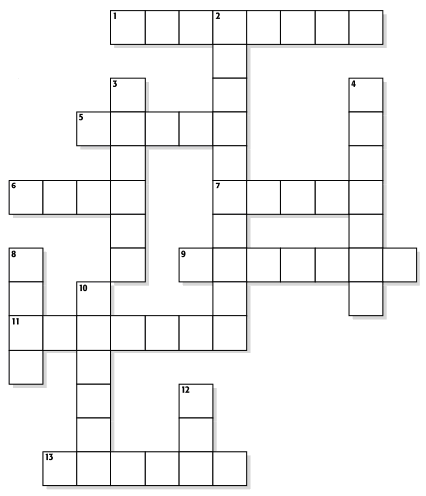
ACROSS
1 a large cupboard for hanging clothes in
5 a small area by the front door of a house
6 a place in the kitchen where you wash dishes, vegetables, etc
7 a room at the top of a house,
under the roof
9 a thing on the roof of a house
that lets smoke go outside
11 something that keeps food
frozen for a long time
13 something that keeps food cold

DOWN
2 a machine that washes plates,
knives, forks, etc.
3 a thing that you use for cooking
with electricity or gas
4 a room where you cook food
8 a long soft seat for more than
one person
10 a room in the part of a house
that is under the ground
12 a small piece of thick material
that you put on the ﬂoor.

Reading

Exercise 6
Look at the flyer and do the tasks that follow.

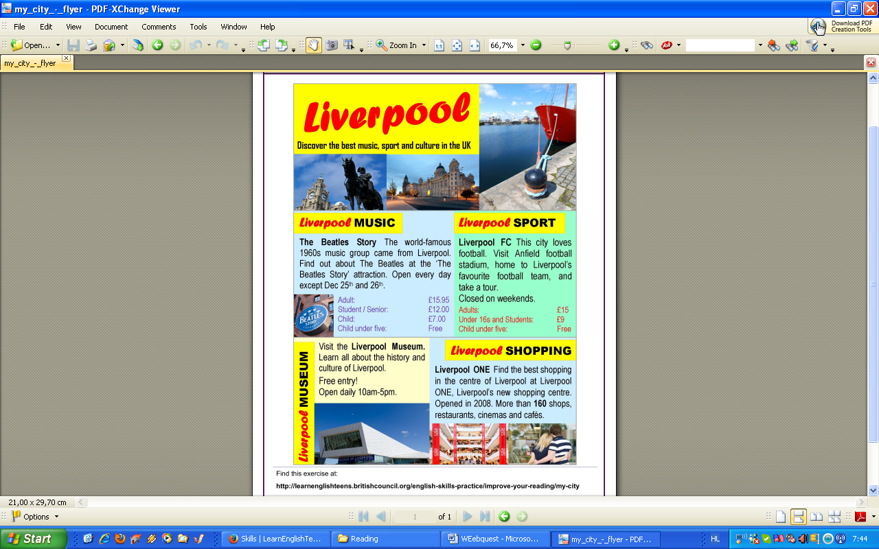

1. Match the sentences with the attraction in Liverpool.

- It is open every day except at
Christmas.
- It opened in 2008.
- You can tour the stadium.
- Children have to pay £7 to enter.
- The price is the same for students and
under 16s.
- There is free entry for everybody.
- It closes at 5pm.
- This is located in the centre of Liverpool.

The Beatles Story | Liverpool ONE Shopping Centre
Liverpool FC | Liverpool Museum

2. Circle True or False for these sentences.

1. The Beatles were a famous rock group in the 1970s. True False
2. There are 2008 shops at Liverpool ONE. True False
3. It costs £15 for adults to tour Anfield stadium. True False
4. Liverpool FC play their games at Liverpool ONE stadium. True False
5. You don't have to pay at the Liverpool Museum. True False
6. Young children can go on the Anfield tour for free. True False

3. Match an attraction in Liverpool for these people and write a – d next to the number 1 – 4.

1…….. “I like music but I don’t like all that modern music and dancing.” (Sam)
2…….. “Well, we don’t have much money.” (George and Doris)
3…….. “My sister and I love buying shoes.” (Yuka)
4…….. “I love all forms of exercise especially team sports.” (Luka)

a. Liverpool Museum
b. Liverpool FC
c. The Beatles Story
d. Liverpool ONE

