Unit 5

Home

Lesson 3

Communication 1

Task 1

Go to http://www.podcastsinenglish.com/pages/freesample.shtml and listen to MOVING HOME about Emily who has just moved houses.
Listen carefully and tick the right column.
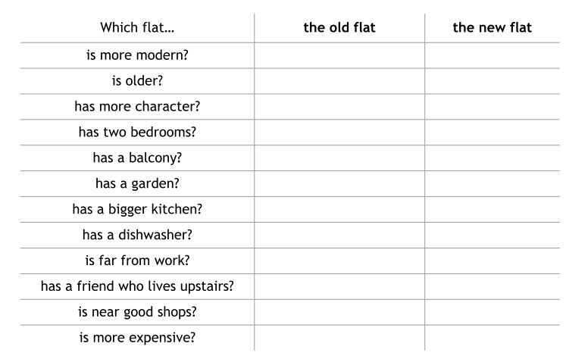

Task 2
Go to http://www.examenglish.com/KET/ket_listening_part4.htm and do the online listening activity on the site. You can check your answers on the page and read the script if you wish.

Communication 2
Writing

Write an email to your English friend and tell him/her about your town/ village.
Use the following questions to help you.

- What is the name of the town/ village?
- Where is it?
- What is there in the town / village?
- What can you do there?
- Why do you like it?

……………………………………………………………………………………………………………………………………………………………………………………………………………………
……………………………………………………………………………………………………………………………………………………………………………………………………………………
……………………………………………………………………………………………………………………………………………………………………………………………………………………
……………………………………………………………………………………………………………………………………………………………………………………………………………………
……………………………………………………………………………………………………………………………………………………………………………………………………………………
……………………………………………………………………………………………………………………………………………………………………………………………………………………
……………………………………………………………………………………………………………………………………………………………………………………………………………………
……………………………………………………………………………………………………………………………………………………………………………………………………………………
……………………………………………………………………………………………………………………………………………………………………………………………………………………

Communication 3
Speaking

Look at the two pictures.

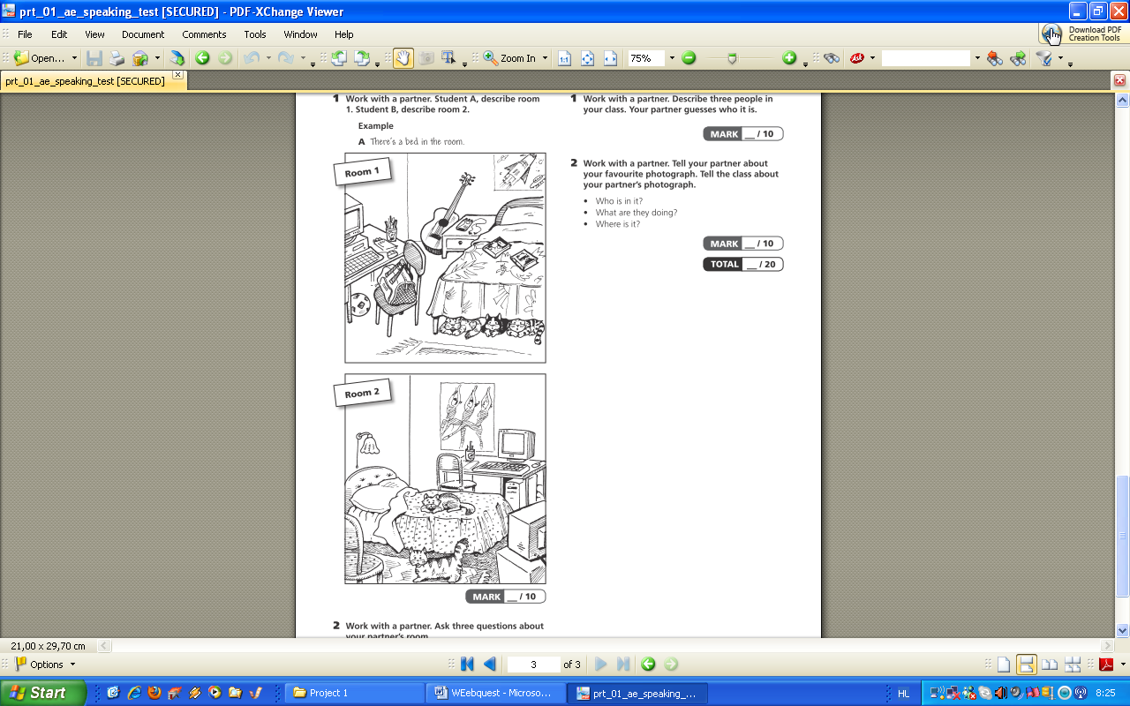

- Compare the two rooms.

- Tell your classmates about your room at home and be prepared to answer their questions.

